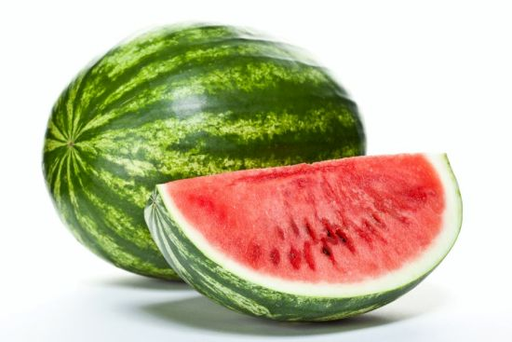

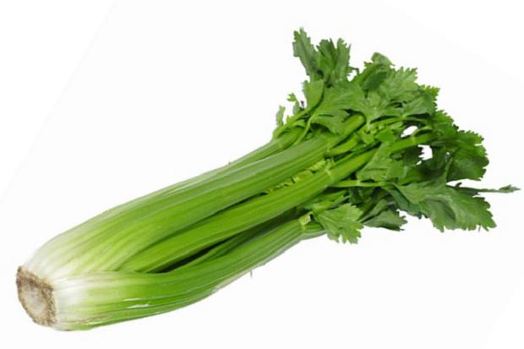

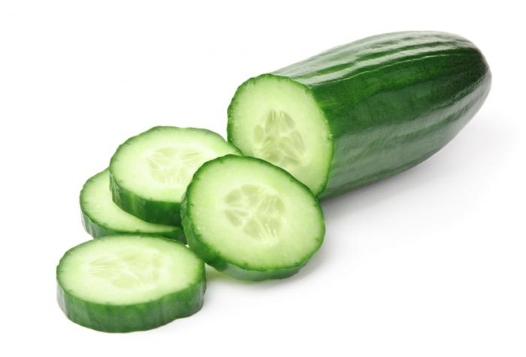

**Healthful Hints**

**3 foods that help you stay hydrated‏.**

The human body is largely made up of water, so it makes sense that consuming water and water-rich produce helps maintain balance and protects against dehydration.  It also helps you detoxify.  Fluids allow kidneys to remove waste products from your blood, sending important minerals back into the bloodstream and flushing the leftover compounds out in your urine.

Here is a quick list of 3 foods that help you stay hydrated.

* **Cucumbers** – Highest ware content of any solid food, 96.7%.  They are low in calories and high in fiber, which makes them useful for both weight loss and digestive health.  Cucumbers also contain an anti-inflammatory flavonoid called Fisetin that appears to play an important role in your brain health. See recipe on reverse.
* **Celery**– Very few calories, just 6 calories per stalk. This veggie is not short on nutrition, however. Celery contains Folate and vitamins A, C and K.  It also helps neutralizes stomach acid and is often recommended as a natural remedy for heartburn and acid reflux.
* **Watermelon** – this juicy melon is also among
* the richest sources of Lycopene, a cancer-fighting
* antioxidant found in red fruits and vegetables.

Of course there are many more foods that help you stay hydrated… but this is a great start for ideas the next time you head to the store.

To Hydration!

Chilled Cucumber Soup with Yogurt and Fresh Mint

Serves 4 as an appetizer or 12 as an hors d’oeuvre  
active time: 20 minutes

**For The Soup:**

1. 1 3/4 lbs (795 g) seedless cucumbers – peeled and cut in 3” pieces (or 2 lbs (905 g) regular cucumber peeled, seeded and cut in 3″ pieces)
2. 1/4 medium red onion – skinned
3. 1 garlic clove – skinned
4. 1 jalapeño – stem removed, halved and seeded
5. 8 large mint leaves
6. 2 tablespoons Extra Virgin Olive or Grapeseed oil
7. 2 tablespoons fresh lemon juice
8. 1 teaspoon maple syrup or honey
9. 1 teaspoon sea salt

1 – 6 oz. (170 g) plain yogurt

1/2 to 3/4 cup spring water to taste

For the garnishes

1. Lemon or Truffle Oil (optional)
2. 1 medium yellow tomato – seeded and cut in 1/8” cubes (or 8 yellow grape tomatoes quartered) – or buy salsa to use as garnish
3. tiny fresh mint leaves
4. Place all ingredients in the bowl of a food processor with 1/2 cup of the spring water. Pulse a few times so the ingredients are coarsely chopped, then process until soup is very smooth, about 2 to 3 minutes. If necessary, thin with the remaining water to the desired consistency.
5. Transfer to a bowl and refrigerate 2 hours or overnight, until well chilled. Place the soup in the freezer for 30 minutes before serving.
6. Ladle soup into chilled soup bowls or cocktail glasses. Drizzle a little lemon oil in the center of each bowl. Garnish with a few tomato cubes, a mint leaf and serve immediately.
7. Cook’s note: The soup can be refrigerated for up to 4 days. Can also be frozen, and served that way and allowed to thaw at place setting.

EASY to En-JOY!

